
HARROW COUNCIL

ADDENDUM

PLANNING COMMITTEE

DATE: 17th February 2021

2/02 | Addendum Item 1:  Relevant Planning History – Section 3 of report (page 115-116)  Add  P/510/93/FUL – Alterations, Two Storey Rear Extension and Change of use to Nursing Home – Granted 20/12/93  Addendum Item 2:  Consultation Responses Update – Section 4 of the report (pages 33-70).  Since the agenda was published, a further 75 objections have been received:  Summary of additional Comments:  - The educational case for the nursery is unproven. The application claims that there is an unsatisfied demand for nursery places in the local Harrow area. However, the applicants have not provided any data or analysis to support their assertion, such that existing local nurseries are full. In fact, our understanding is that there are plenty of places available in existing nurseries in the area.  - The traffic will generate noise as will five groups of 28 children using the garden from 9am-5pm. The noise report does not sufficiently cover traffic noise. The acoustic fence will be insufficient.  - The applicant has only analysed the best case for traffic movements. The transport report was done in a period of dry, warm weather before the pandemic with increased use of private transport. Winter will be different.  - The applicant has significantly over-estimated the number of families that will walk and then go to work.  - The applicant has provided NO information about the effect of traffic and parking on surrounding streets including Rowlands Avenue, Cedar Drive, Royston Grove, Royston Park Road, the Avenue etc.  - It seems that there is Asbestos in the building. There is NO detailed contamination report.  - There are bats in the neighbourhood. A bat survey is required.  - The junctions into and out of the Avenue onto the Uxbridge Road and Royston Park Road onto the Oxhey Lane are insufficient for additional traffic. Congestion is significant on Rowlands Avenue and Cedar Drive.  - Station parking affects the lower end of the Avenue, Cedar Drive and Royston Grove as a result of the CPZ, more parking will be required for staff at the new 78 bed care home at the end of Oakleigh Road.  Further comment from Raymond Ashall for The Oakleigh Road Appeal Funder Group:  “I can now see that a copy of the planning application ref no: EAST/510/93/FUL decision notice (without the approved plans 211/01 & 211/02A) was attached as an addendum (although it would have been useful if this had been provided to me direct before now).  The title of the planning application is listed as;  "Alterations, two storey rear extension and change of use to nursing home with car parking".  However, having now examined this document, I would reiterate my previous opinion that Class T criteria cannot be used in this case because of the stated planning condition number 6 which states;  CONDITION 6  "Notwithstanding the submitted plan, the use hereby permitted shall not commence until the car parking, turning and loading area(s) have been constructed and surfaced with impervious materials, and drained in accordance with details submitted to, and approved in writing by, the local planning authority. The car parking spaces shall be permanently marked out and used for no other purpose, at any time, without the written permission of the local planning authority".  REASON  "To ensure the satisfactory provision of parking areas, to safeguard the appearance of the locality and in the interests of highway safety".  At no time, has 'written permission' in the form of a Section 73 variation of condition application or a planning application for change of use been sought in writing. Indeed, the car-parking spaces would have to be 'identical to the ones shown on any approved plans'.  It is therefore considered that because it states, "The car parking spaces shall be permanently marked out and used for no other purpose, at any time, without the written permission of the local planning authority" this relevant lawful planning condition no. 6 restricts the use of the site to a nursing home as shown on approved plans 211/01 & 211/02A and Class T criteria cannot be used in this case.  The correct way forward would therefore be for the applicant to submit a formal planning application for a registered day nursery use because Class T legislation cannot 'override' any previous approval or formally amend the lawful planning conditions attached thereto.  In summary, planning condition no 6. of planning reference number EAST/510/93/FUL prevents determination under Class T criteria.”  Legal Advice sought by officers on the above comments states:  The case law on this, as stated in the Dunoon case and subsequent cases, is that for a condition to remove permitted development rights under the GPDO, it has to specifically refer to that fact. Condition 6 does not do that. It merely specifies the condition subject to which the previous permission could be exercised or circumscribed the ambit of the previous use. To remove permitted development rights the previous permission should have included a condition that specifically stated that it could not be used for any other purpose authorised under any provision/s of the GPDO”.  Addendum Item 3:  Amend Condition 5:  REASON: To comply with Class T.2 (b)(ii) of the General Permitted Development Order 2015 (as amended)  Addendum Item 4:  ADD Condition 9:  The external space shall not be used for play or learning outside the following times: -  a: 09.00 hours to 17.00 hours, Monday to Friday inclusive, including Bank Holidays without the prior written permission of the local planning authority.  REASON: To comply with Class T.2 (b)(ii) of the General Permitted Development Order 2015 (as amended)  Addendum Item 5:  Add Appendix 7 – APPLICANTS STATEMENT IN REPLY TO Oakleigh Road Funders Group Formal Objection  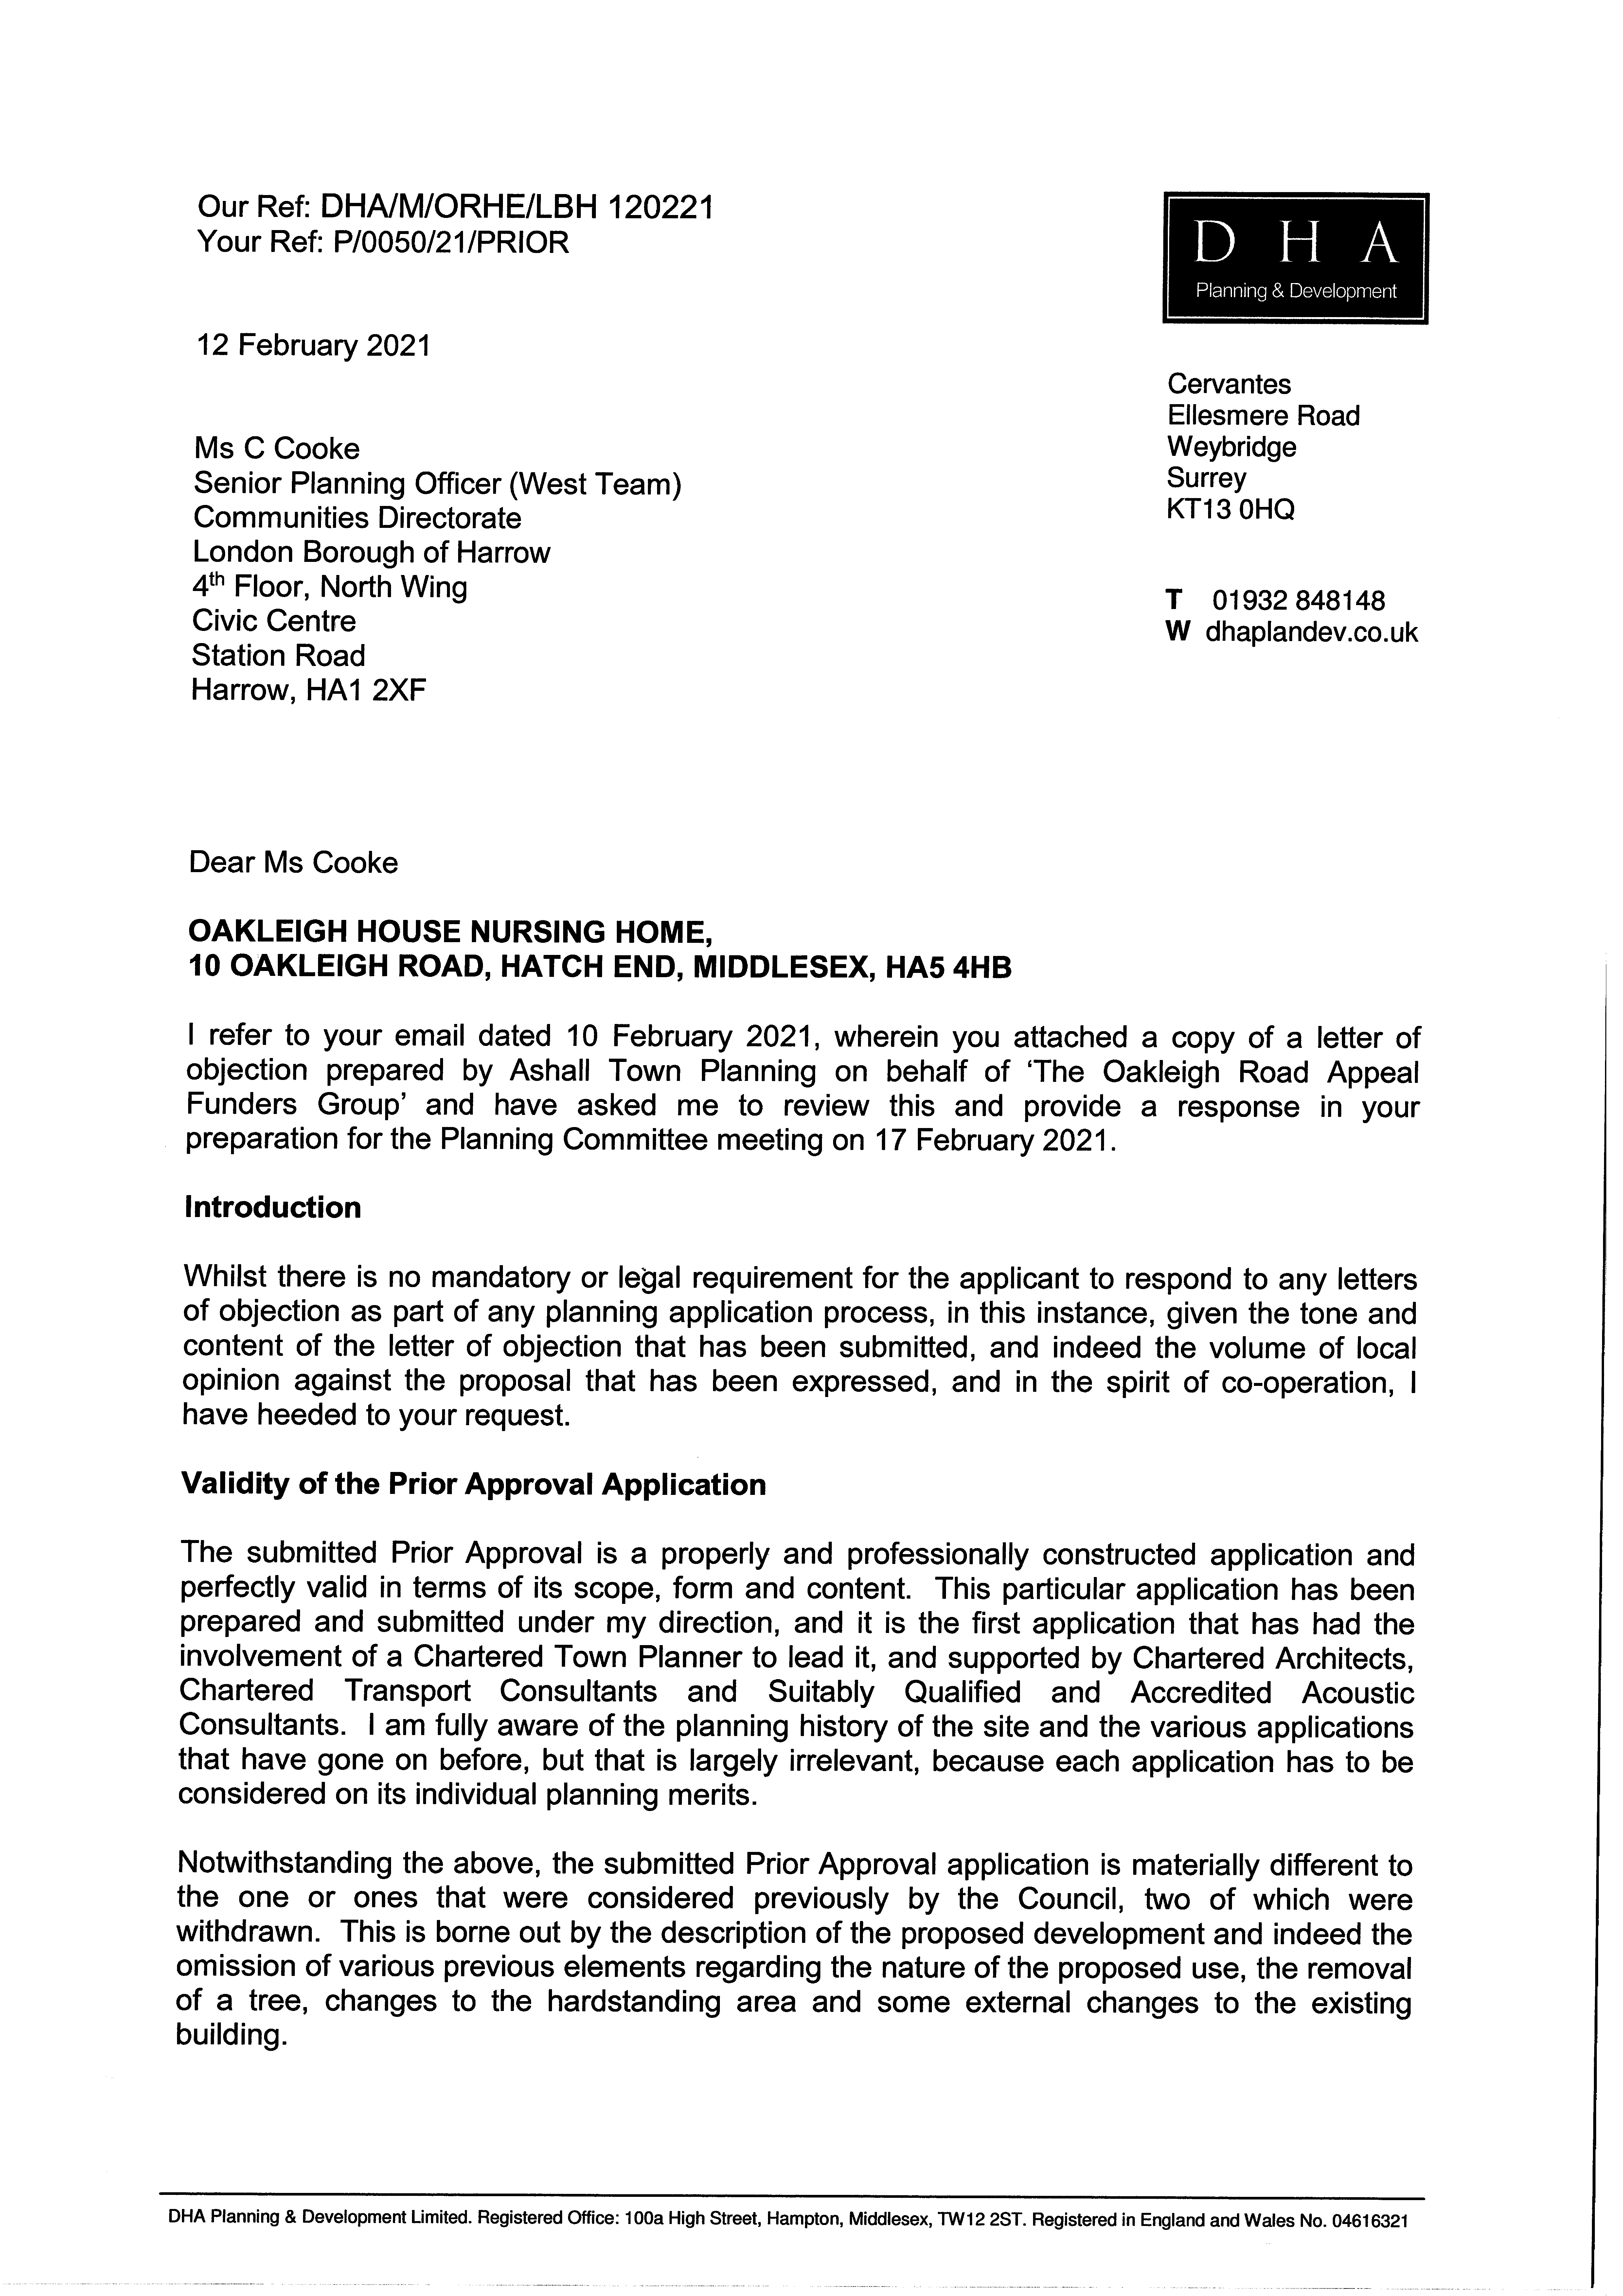  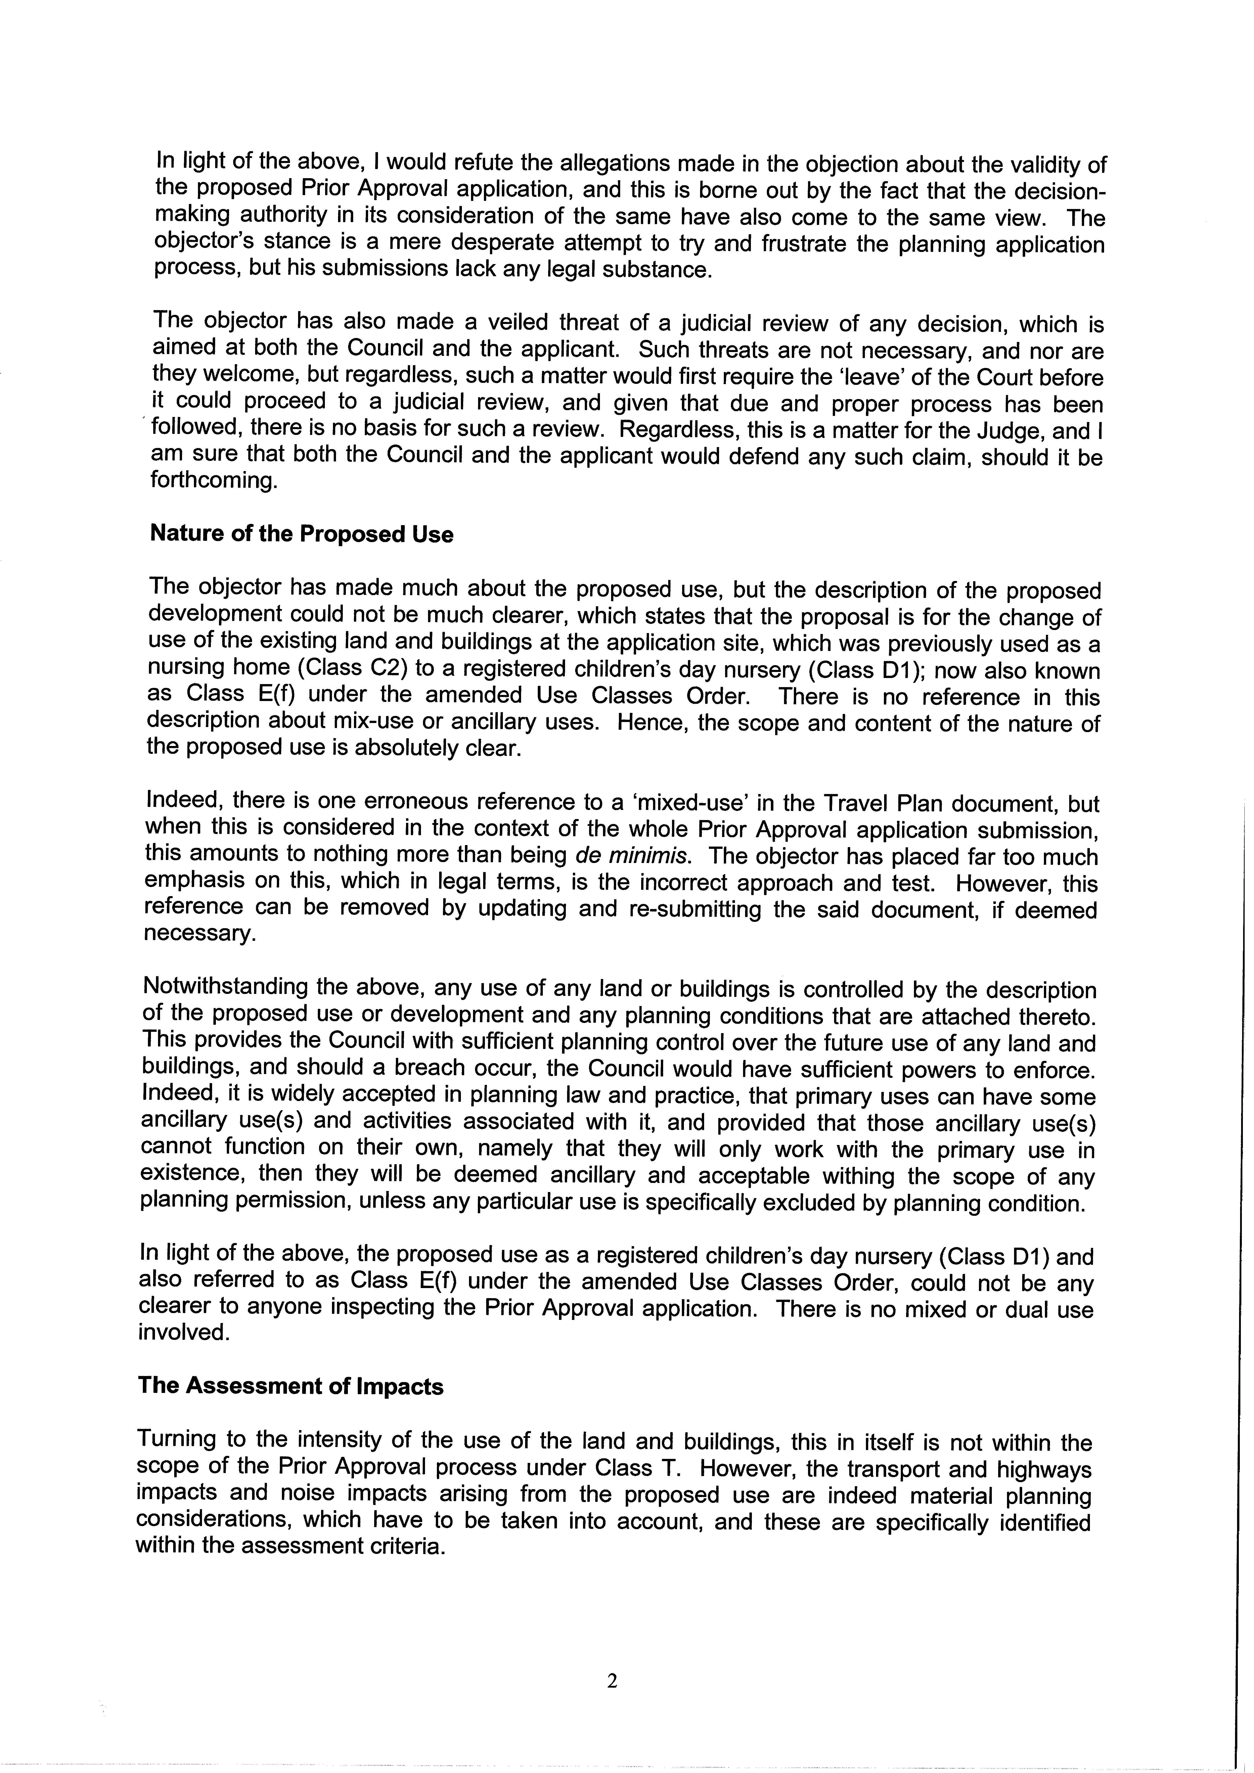  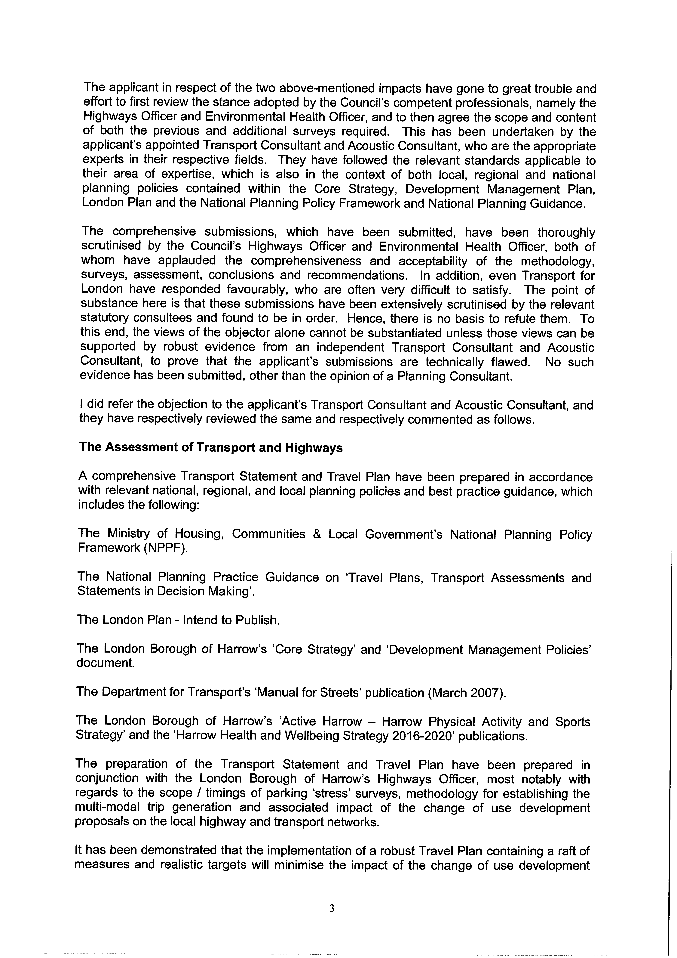  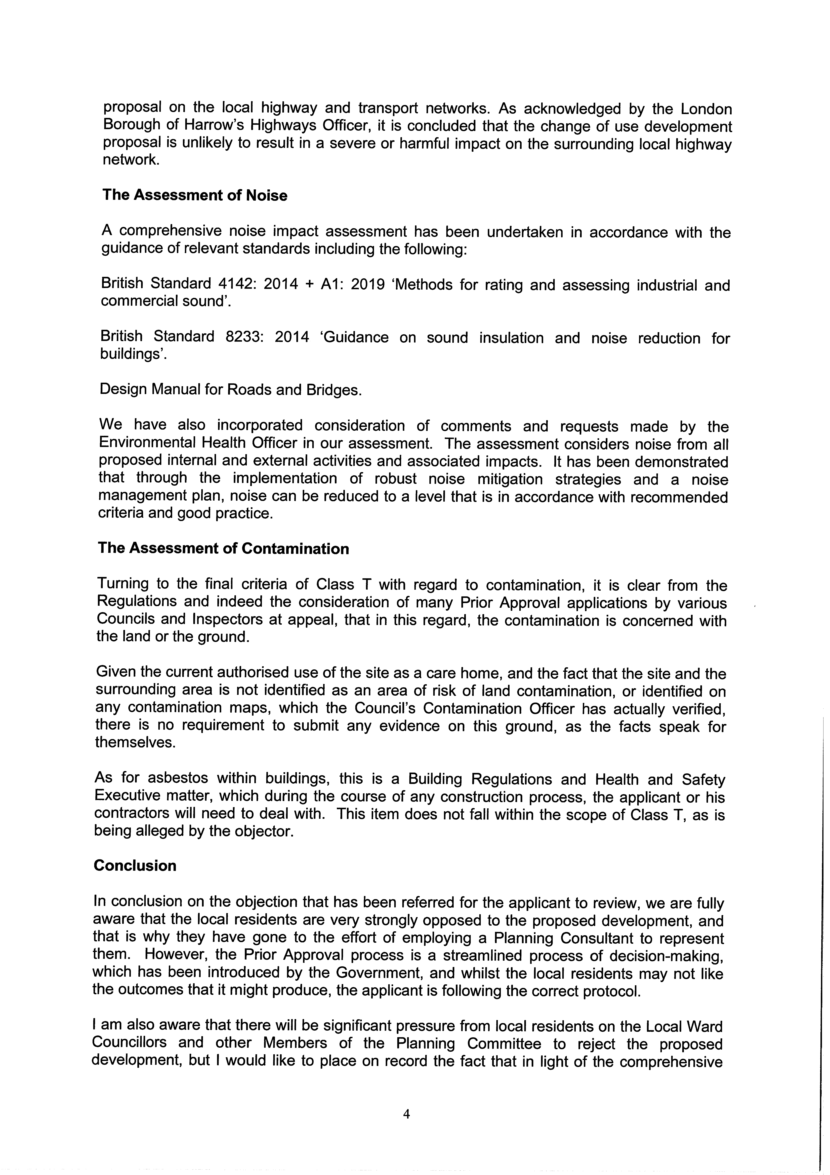  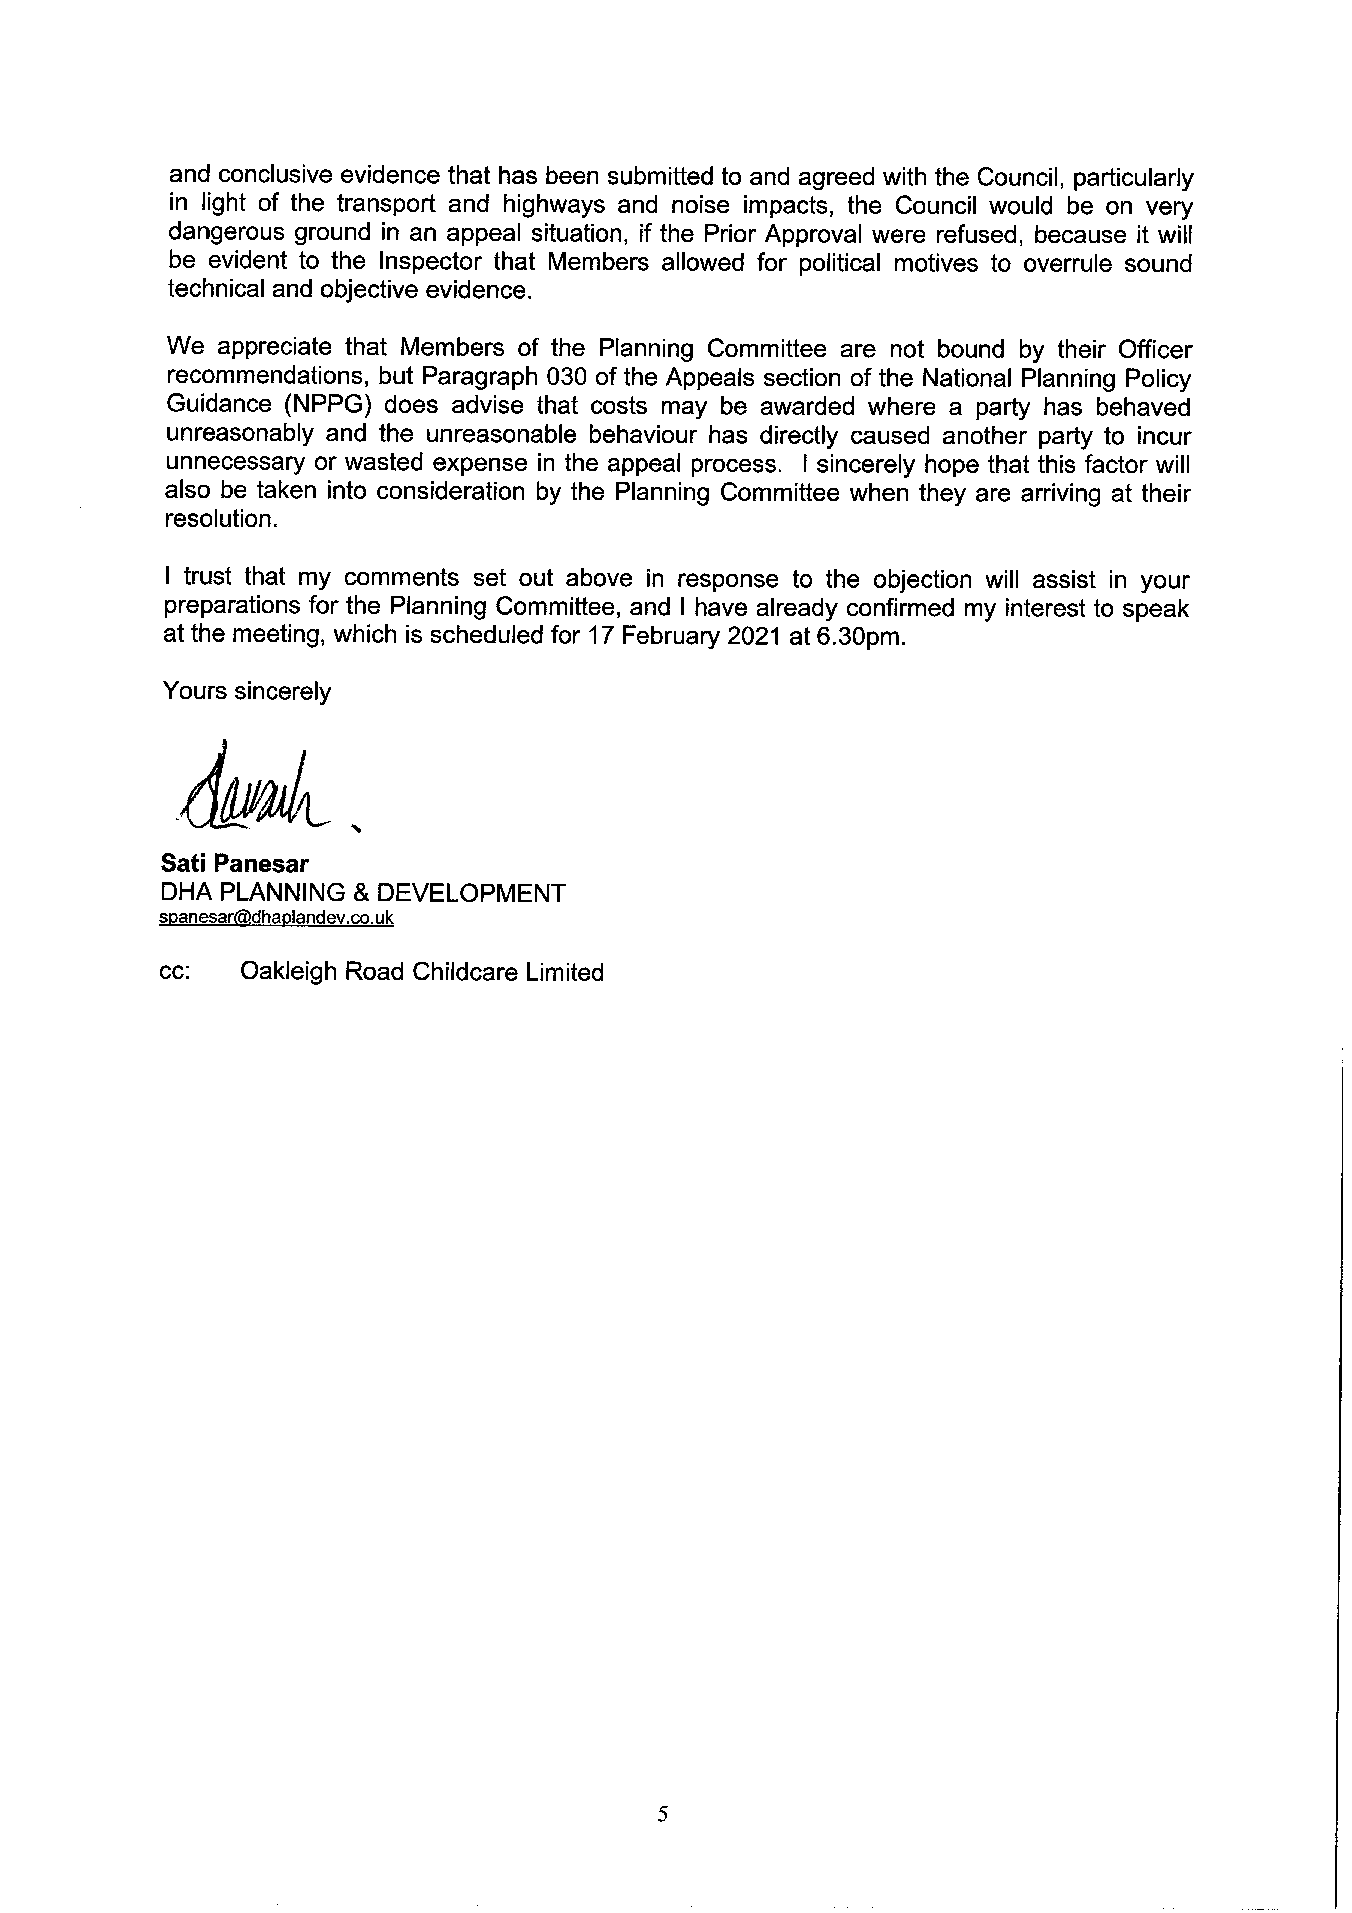
AGENDA ITEM 10 – REPRESENTATIONS ON PLANNING APPLICATIONS

Agenda Item |  | Application Address | Speakers
2/01 |  | Cornwall Court, Cornwall Road, Pinner, Ha5 4lr, P/4252/20/Prior | Cllr John Hinkley (Back Bench)  Cllr Jean Lammiman (Back Bench)
2/02 |  | Oakleigh House, P/0050/21/Prior | David Glassman (Objector)  Sati Panesar (Agent for Applicant)  Cllr John Hinkley (Back Bench)  Cllr Jean Lammiman (Back Bench)

